**Exercise 1**. Create an empty virtual machine and configure it.

Windows 10 (64-bits):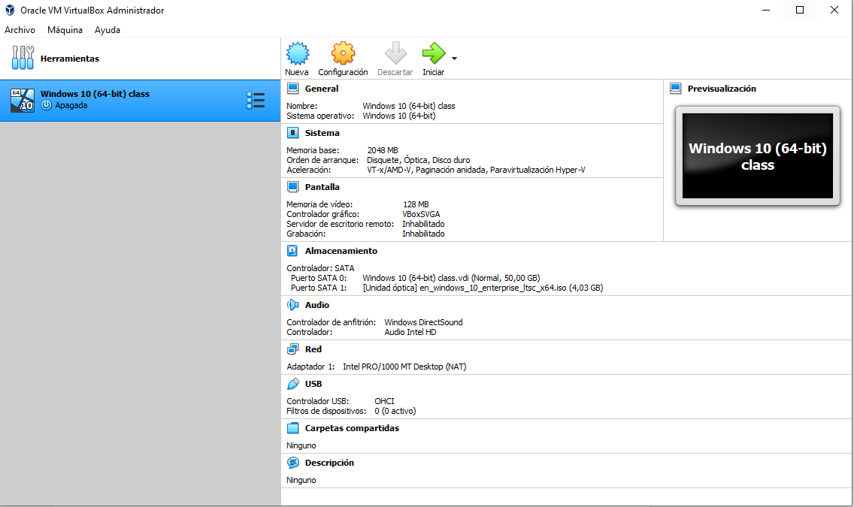

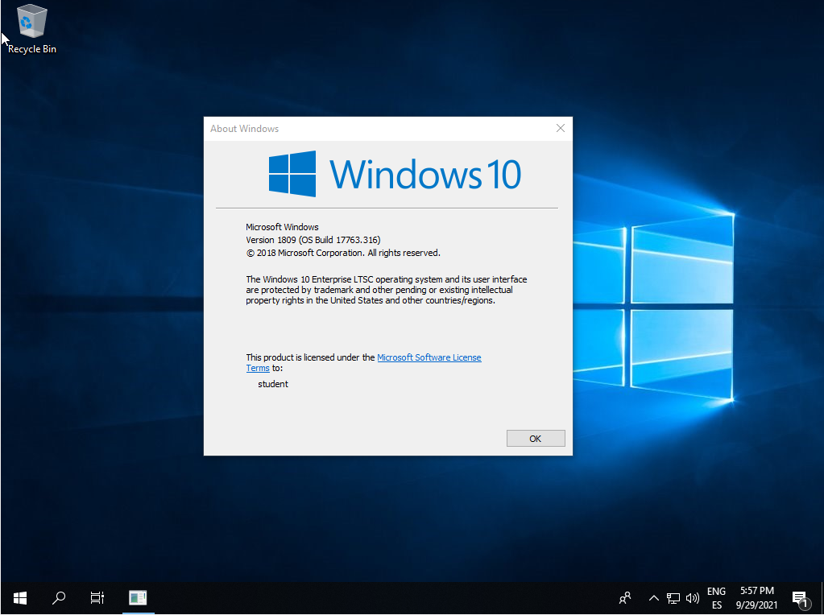

2GB of RAM memory and boot order: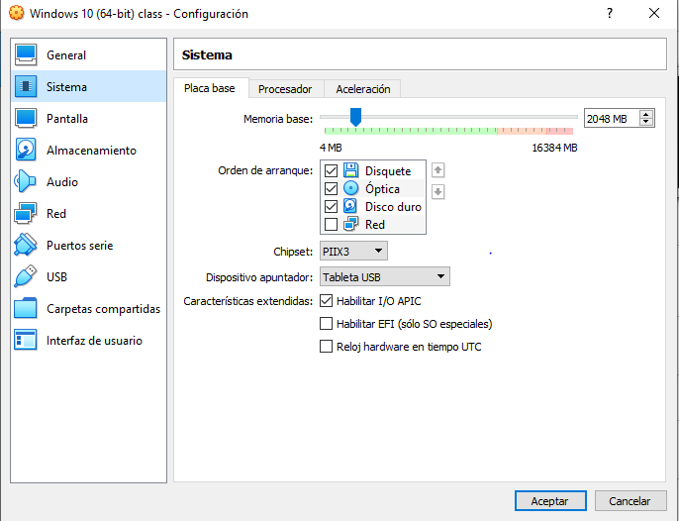

Two hard drives: one with 50GB for the OP and another one with 30GB empty: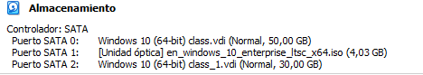

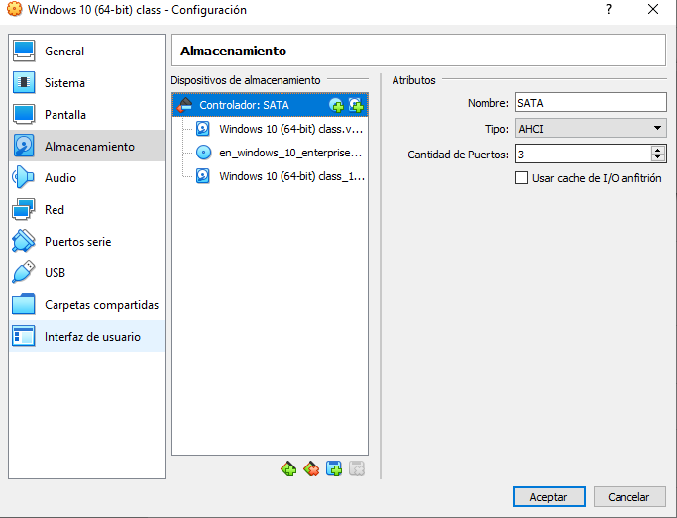

**Exercise 2.**  USB 3.0 support:

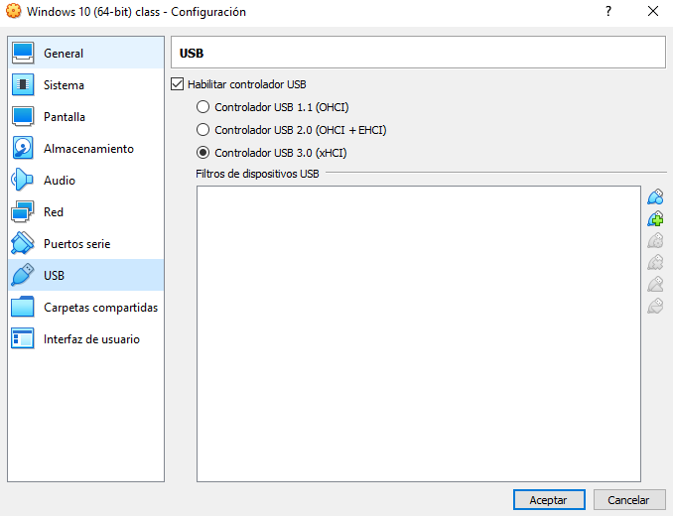

Shared folders:

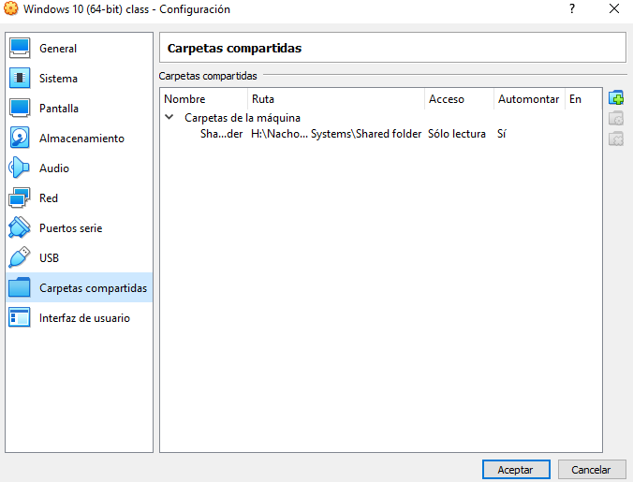

Internet connection including access to the rest of computers of the network:

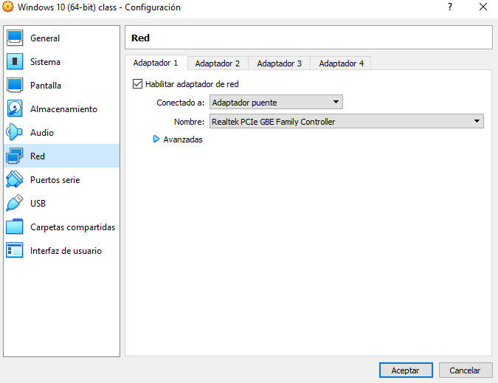

You will be able to copy and paste from the host to the guest and vice versa:

